Comm5961 Final project website

Sakura Trip

Ren Ruiwen (1155131527)

**User Needs**

Since there have already existed so many websites about traveling or trip advice, it has no competitiveness if I do another one. So, I observe what my friends post online about their trips during this year, I find that several of them posted pictures when they travel to Japan and go for the cherry blossom season. And then I search online about the information about the cherry blossom, whereas almost all websites are about segmental information, there is no one could show me the general information about cherry blossom. For example, if I want to know the timeline of cherry blossom systematically and spots of a specific city, I need to search it by keywords, and it takes a lot of time to know the general situation because I need to do lots of research.

To solve this problem, my website aims to help the traveling-lovers build a general and macroscopical concept about the cherry blossom season in Japan. And this website severs to 1) Helping to plan a schedule for those who want to travel for the cherry blossom season in Japan. 2) Displaying the fun and interest of traveling to Japan for a cherry blossom season and encouraging users to go. Based on all information and data collection, there are three major needs from the users: 1) The general information about the cherry blossom timeline. 2) Where to find the best place to enjoy the cherry blossom. 3) What else can I do with the Japanese cherry? A Journey map below is composed based on the users' needs (See Figure 1.)

**User Journey Map**

|  |  |  |  |
| --- | --- | --- | --- |
| **Users Persona** | **Stage** | **Purpose** | **Result** |
| 1. Travelers who are searching for a cherry blossom trip in Japan 2. Japanese cherry lovers | Looking for cherry blossom information | Planning a trip to Japan / Just for fun | Find my website |
| Browse | 1. Watching the videos about the cherry blossom. | Be interested in the cherry blossom trip. |
| 1. Want to know the timeline of cherry blossom season. | The timeline page |
| 1. Want to know where the places are to enjoy the cherry blossom? | The spots page |
| 1. What recommendations can reserve and where can reserve? | The Before you go page |
| 1. Which airport should I choose and where is that? |
| 1. What else about Japanese cherry is interesting could attract me to go for a trip? | The special experience page |

*Figure 1.* User journey map

**Scope**

In this part, the diagram will demonstrate how the website works as a “media” in the flow. The website aims to provide what users need and let users obtain what exact they want. The website needs to be updated and add more information with the users increasing. The diagram shown below (See Figure 2.) is the scope of how this website works.

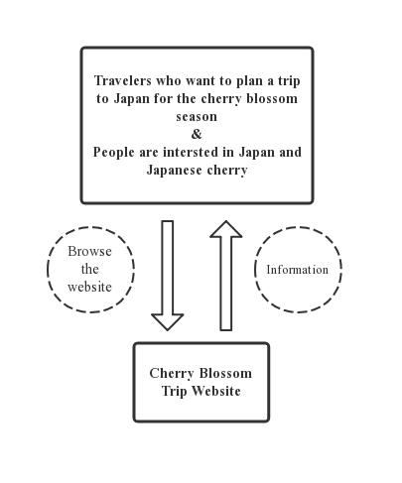

*Figure 2.* Scope

**Structure and Skeleton**

1. **Structure**

* **Site map**

To come up with the general idea of the structure of the whole website, I build the site map to help me generate the frame of my website. (See Figure 3.)

*Figure 3.* Site map

1. **Skeleton**

To make the idea become the real website, figures shown below are the low fidelity wireframe prototypes to build the layout and design of each webpage.

*Figure 4.* Home

*Figure 5.* Homepage

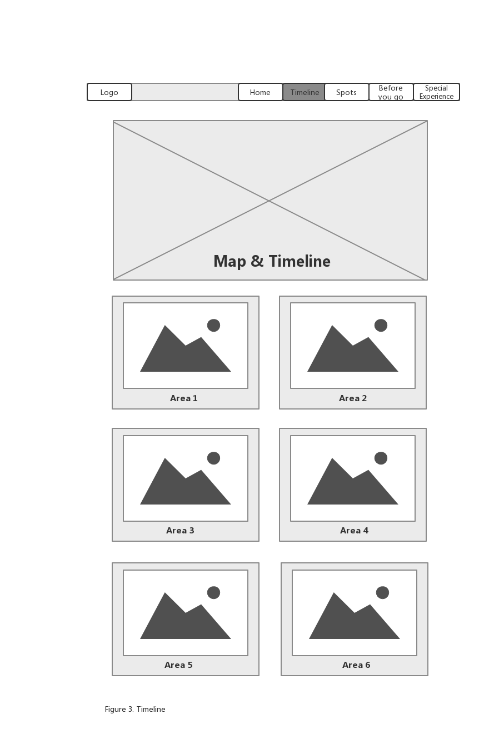

*Figure 6.* Timeline

*Figure 7.* Spots

*Figure 8.* Before you go

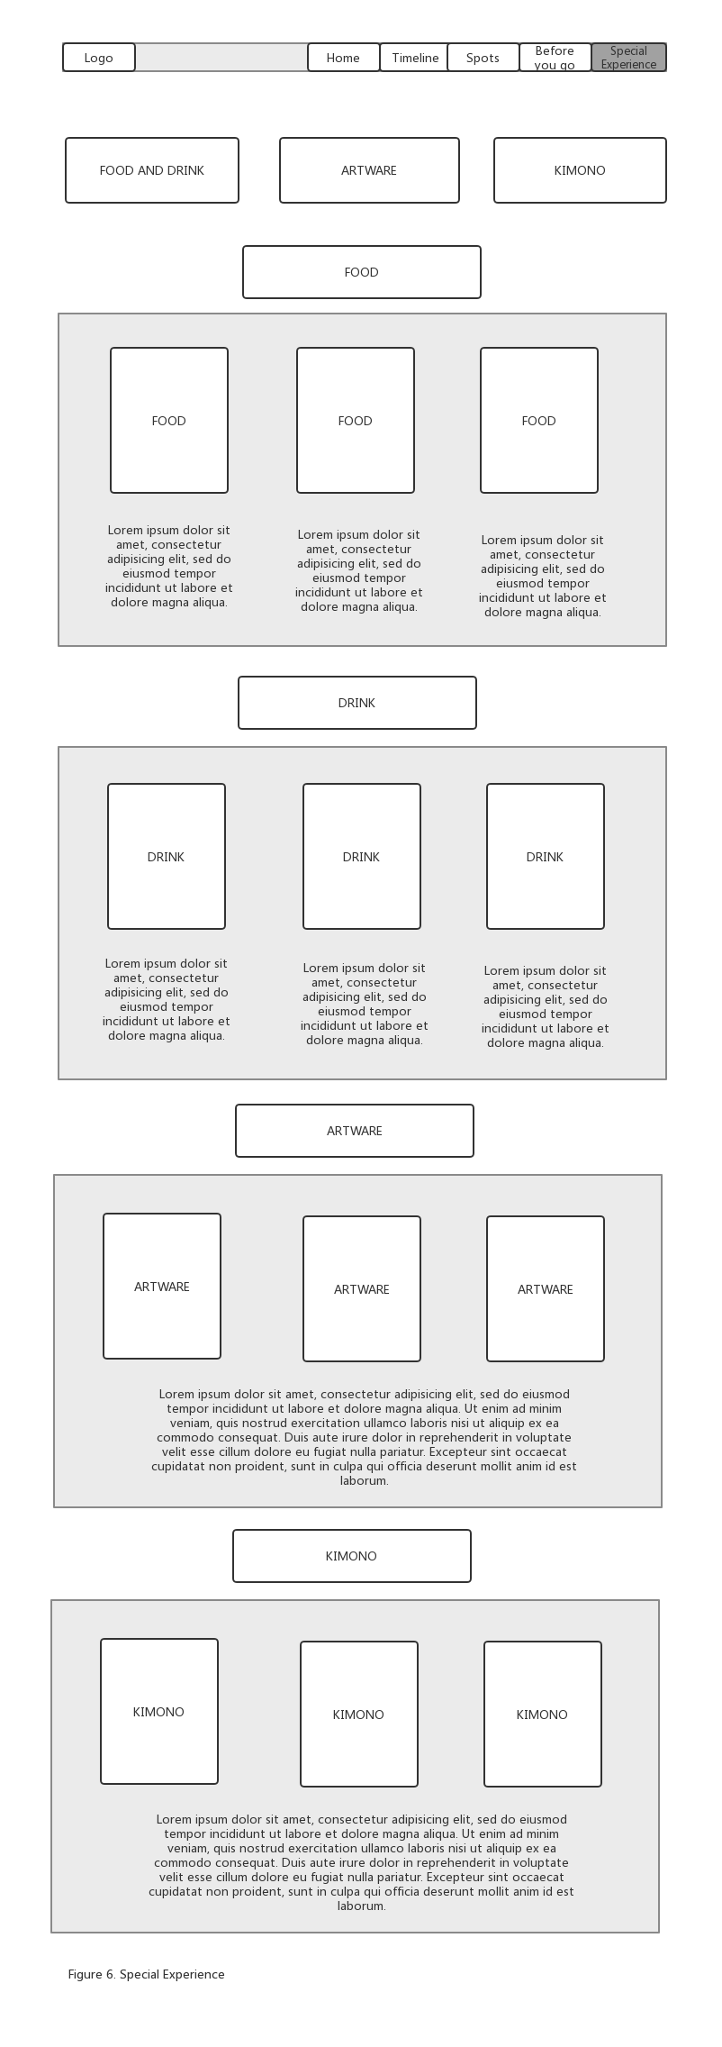 *Figure 9.* Special Experience

1. **Qualitative Usability Test**

After completing the wireframes, it’s important to know does the website make sense to the users and would it work fluently and well. In order to test whether my layout and design are efficient or not. I invite five mainland friends all have aboard traveling experience and can understand English to do the usability test.

For three of the target users, I made a video call to them and ask them to let me see their faces so I can observe their reaction while answering my questions. And the other two of five users, I did the test with them face to face. Before starting the test, I will tell the users what I am doing is to let them browse the website and they need to answer my questions about what they saw. And I told them they could say anything they want to about this website and there is no need to be hesitate because they are my friends. Also, I explained that there are six pages and eight questions in total in advance.

Then I will let the users browse the website and ask them questions during different steps. Below is the table about the steps, questions and the answer from those 5 testers.

|  |  |  |  |  |  |  |
| --- | --- | --- | --- | --- | --- | --- |
| **Step** | **Question** | **User 1** | **User 2** | **User 3** | **User 4** | **User 5** |
| Home and Homepage | Q1. What is this website about? | Japan travel | Cherry blossom trip | Travel website | Cherry blossom trip | Cherry blossom trip |
| Timeline | * Q2. Does the layout of the “area” seem methodical? | Need clearer label | Yes | A little bit repetitive | Yes | Yes |
| * Q3. If you want to go to Area 1 to find some spots, do you know where to find that? | Yes | Yes | I want to click the “Area” button in timeline page | Yes | You should change “Spot” to “location” |
| Special Experience | Q4. If you are interested in Japanese cherry related food and drink, do you know where to find that information? | Special experience | Yes | Maybe in Special experience | Yes | Yes |
| Q5. Are you interested in this part? Is this fun for you? | Yes | Yes,  the people who like cherry will like this | Yes | Normal | Yes |
| After browsing  All pages | Q6. Does the website make sense to you? | Yes | Yes | Yes | Yes | Yes |
| Q7. Does the connection between each page strong? | Normal | Yes | Yes | You should combine the home and homepage | You should combine the home and homepage |
| Q8. What should be changed to make the website more consistent? | It’s clearer and more efficient to put timeline and spots together | Timeline and spots seem repetitive | In “spots” section, the position of map and area need to be changed | Booking/Airbnb and other recommendations should directly link to their homepages | Combine spots and timeline |

*Figure 10.* Usability Test

As shown above (See Figure.10), testers have given different feedbacks on the general design and layout of the website. They have a clear idea of what this website is about, which is the most important one. The instruct taps at the top of the website make sense to them. Generally, the website is clear and easy to understand. However, they also demonstrate some issues about the website. The first one is that the Home and homepage should be combined to make it more efficient. Moreover, the “timeline” and “spots” are supposed to be connected or combined, so it is easier and methodical for users, which means users could simply check the spots' information by clicking the area buttons. There is no need to separate these two parts. All in all, during the prototyping usability test, these are the two main suggestions to help me make the website more fluent and enhance efficiency.